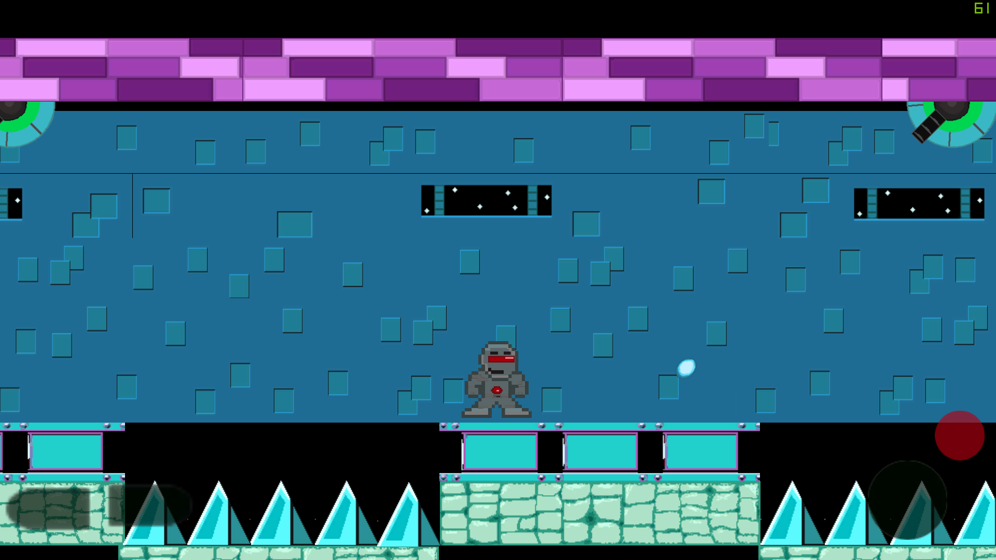

This game was made for the Android Platform with Unity 2D engine. The game is a platformer with the goal to get through the level without being hit. The game has obstacles like turrets that shoot projectiles, spikes, and moving platforms. Everything in this game was done by hand. I developed this game for my Embedded game design course where the focus was all on embedded game from consoles to mobile. First project created in Unity.